# Deployment of index.html from repo to docker container
-Anushka Vijay Gaikwad

- Installed and started docker on JM
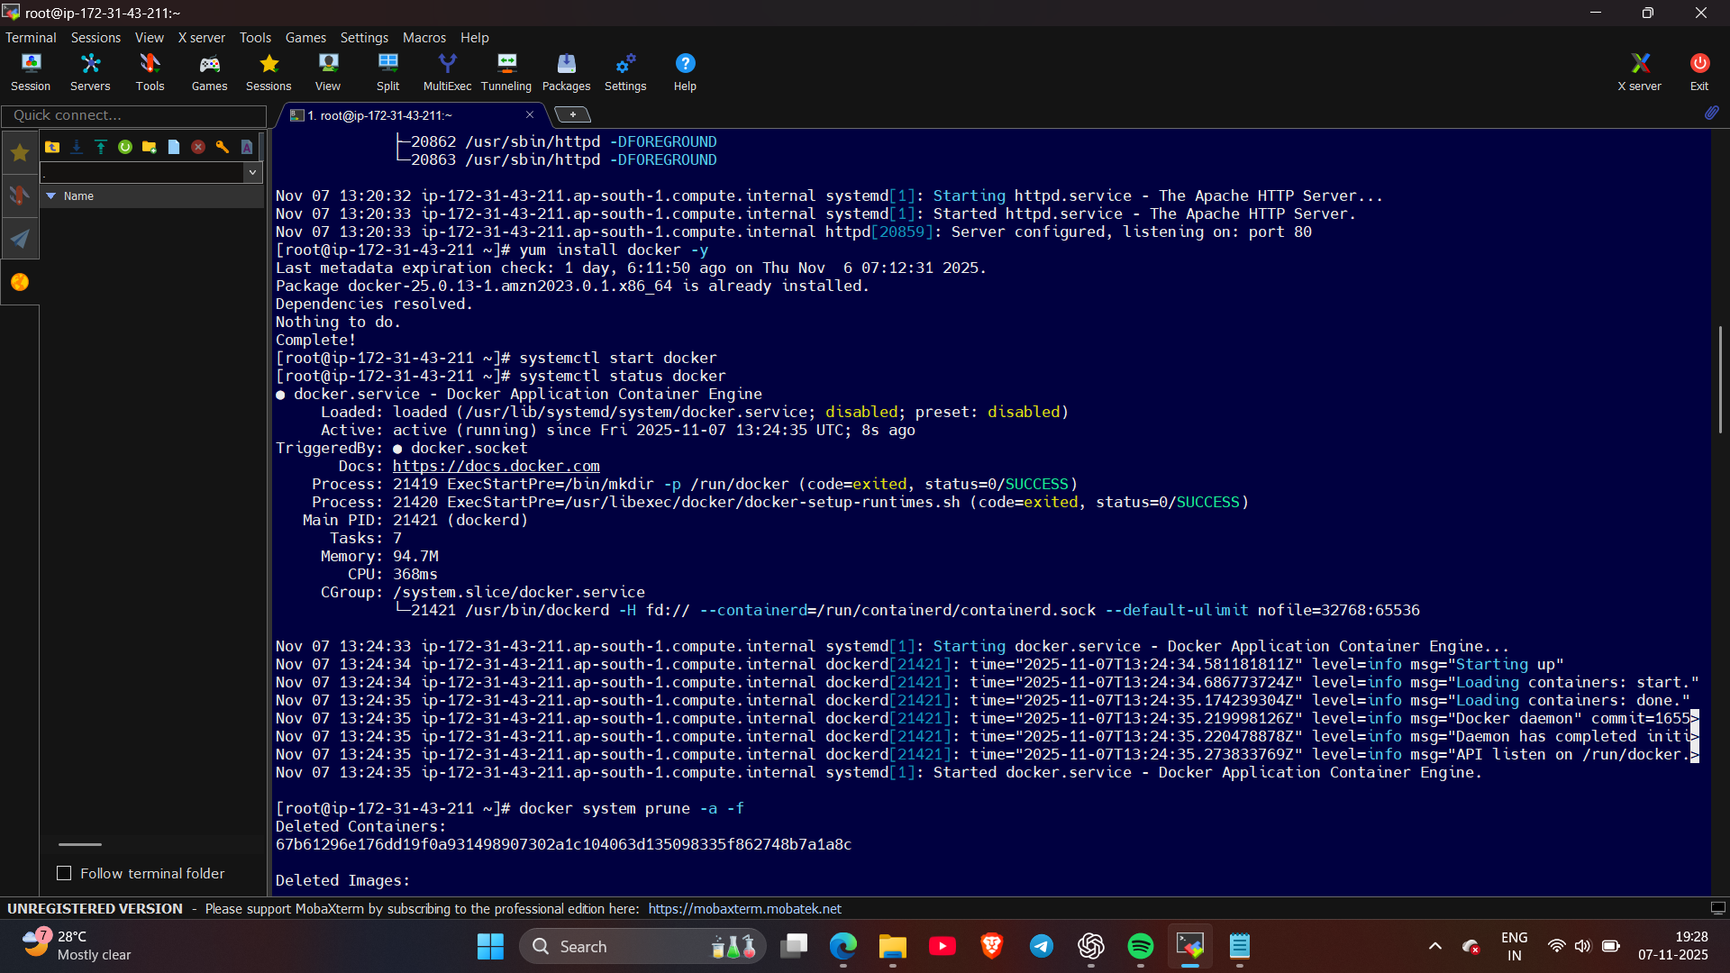
- Created 3 repository:
Repo 1 : 2025Q1 branch in that deployed index.html file
Repo 2 : 2025Q2 branch in that deployed index.html file
Repo 3 : 2025Q3 branch in that deployed index.html file
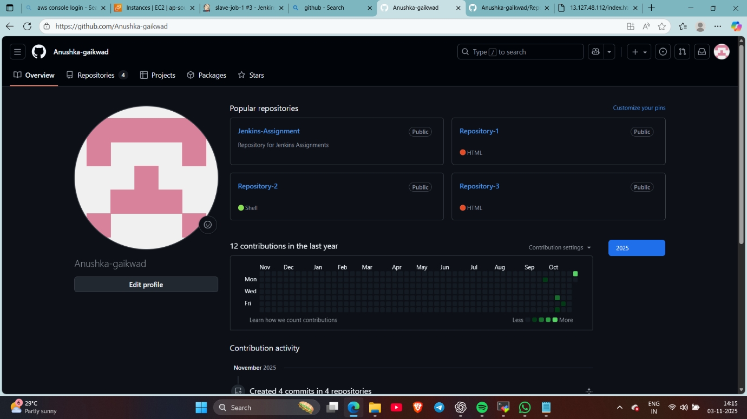

- Create job-1 declarative pipeline : (cloned repo and created container and copied index.html file in that on port 80)
pipeline {

agent {

label {

label "built-in"

}
}

stages{

stage ("deploy repository") {

steps {

echo "cloning repository..."
git branch: '2025Q1' , url: 'https://github.com/Anushka-gaikwad/Repository-1.git'

}
}

stage ("deploy file") {

steps {

script {

sh '''
docker rm -f c1
docker run -dp 80:80 --name c1 httpd
docker cp index.html c1:/usr/local/apache2/htdocs/index.html
docker exec c1 chmod 777 /usr/local/apache2/htdocs/index.html

'''

}

}

}

}

}

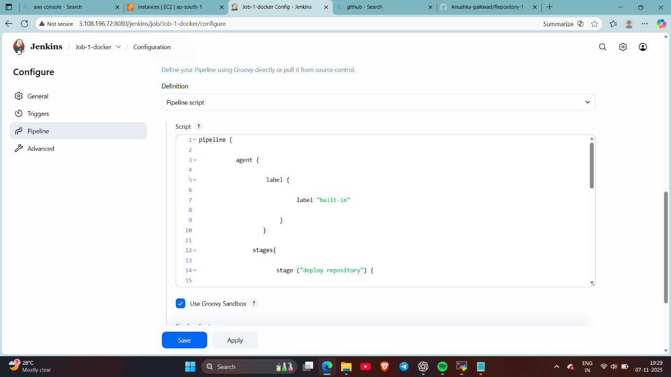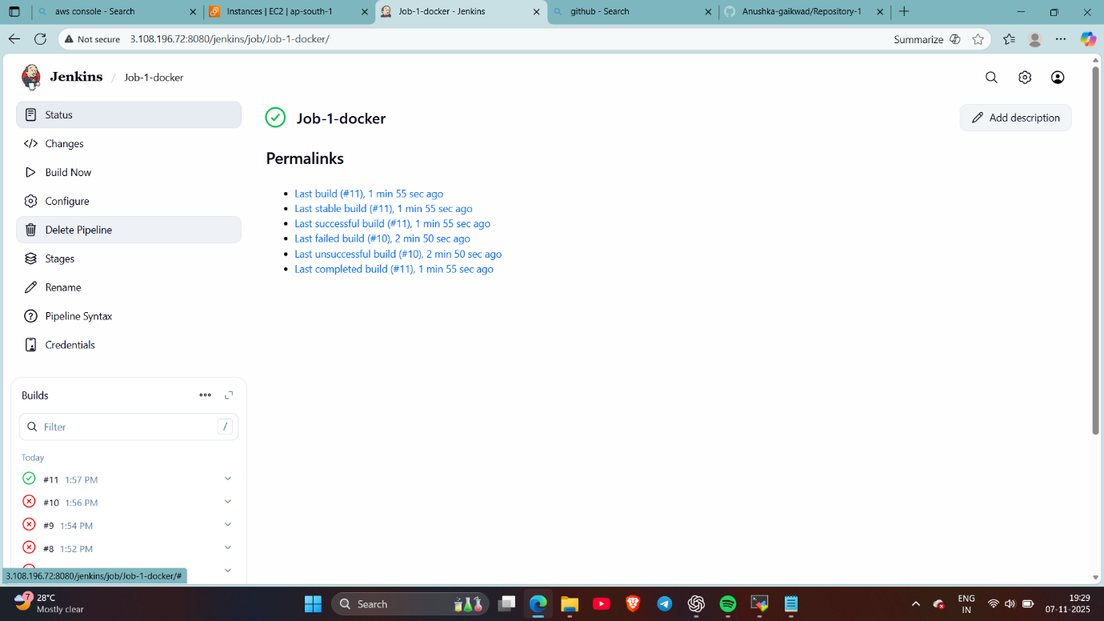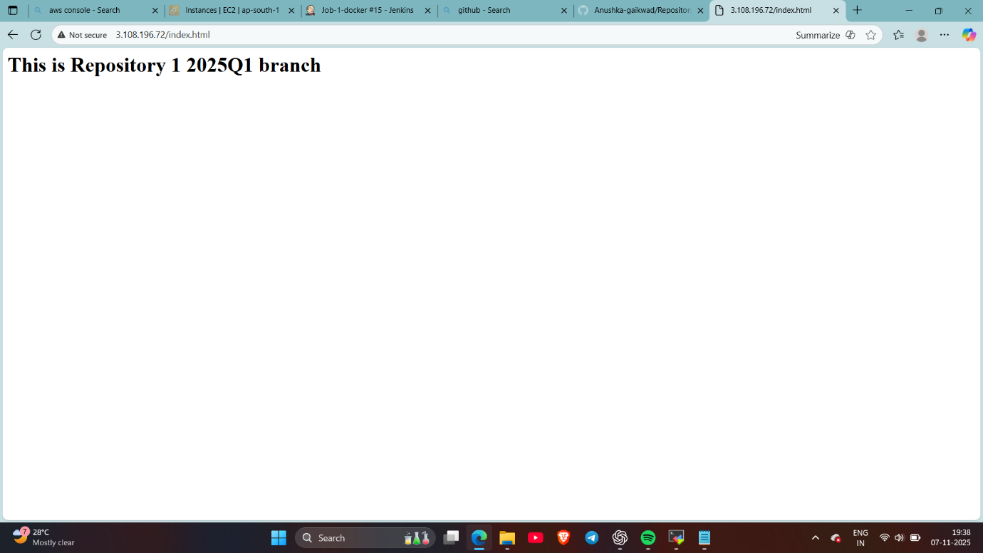

- Create job-2 declarative pipeline : (cloned repo and created container and copied index.html file in that on port 90)
pipeline {

agent {

label {

label "built-in"

}
}

stages{

stage ("deploy repository") {

steps {

echo "cloning repository..."
git branch: '2025Q2' , url: 'https://github.com/Anushka-gaikwad/Repository-2.git'

}
}

stage ("deploy file") {

steps {

script {

sh '''
docker rm -f c2
docker run -dp 90:80 --name c2 httpd
docker cp index.html c2:/usr/local/apache2/htdocs/index.html
docker exec c2 chmod 777 /usr/local/apache2/htdocs/index.html

'''

}

}

}

}

}
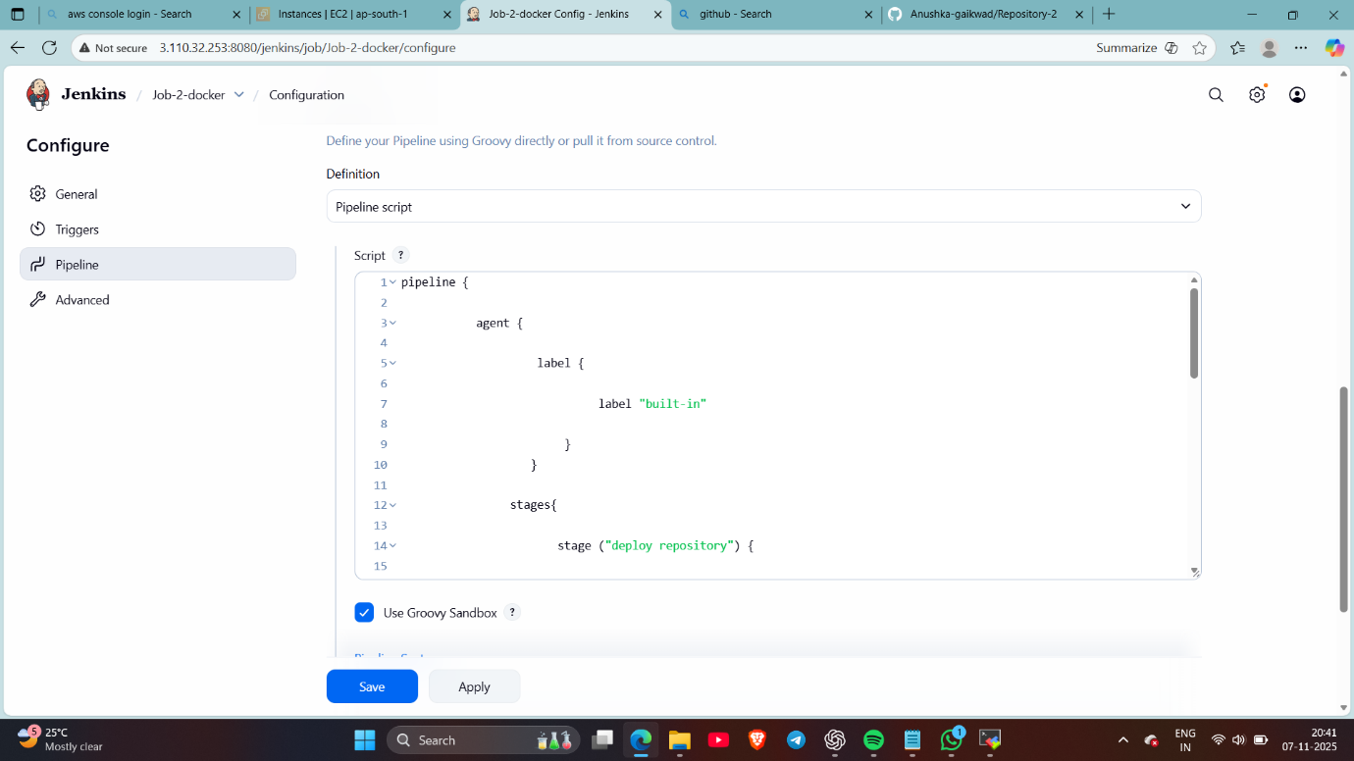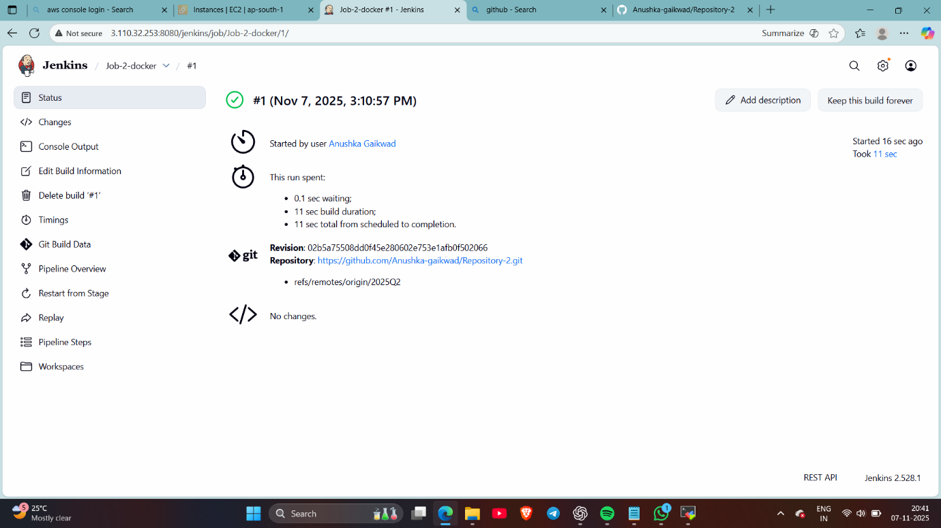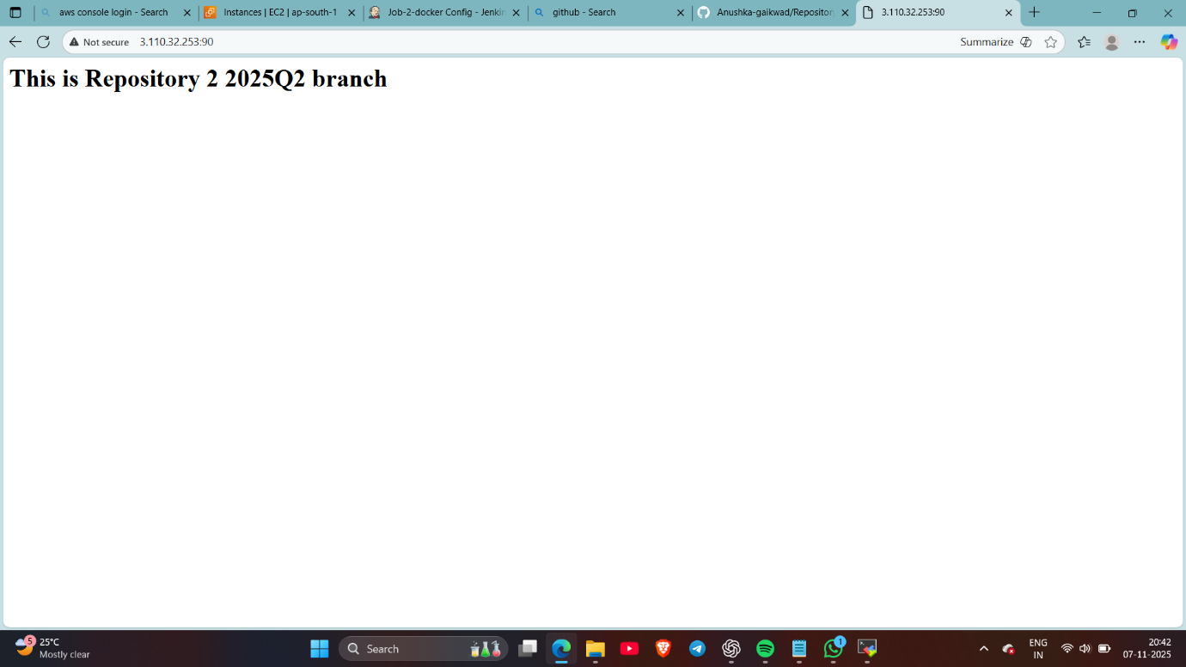

- 5. Create job-3 declarative pipeline : (cloned repo and created container and copied index.html file in that on port 8090)
(8080 port is of Jenkins so I’ve changed my containers port)

pipeline {

agent {

label {

label "built-in"

}
}

stages{

stage ("deploy repository") {

steps {

echo "cloning repository..."
git branch: '2025Q3' , url: 'https://github.com/Anushka-gaikwad/Repository-3.git'

}
}

stage ("deploy file") {

steps {

script {

sh '''
docker rm -f c3
docker run -dp 8090:80 --name c3 httpd
docker cp index.html c3:/usr/local/apache2/htdocs/index.html
docker exec c3 chmod 777 /usr/local/apache2/htdocs/index.html

'''

}

}

}

}

}

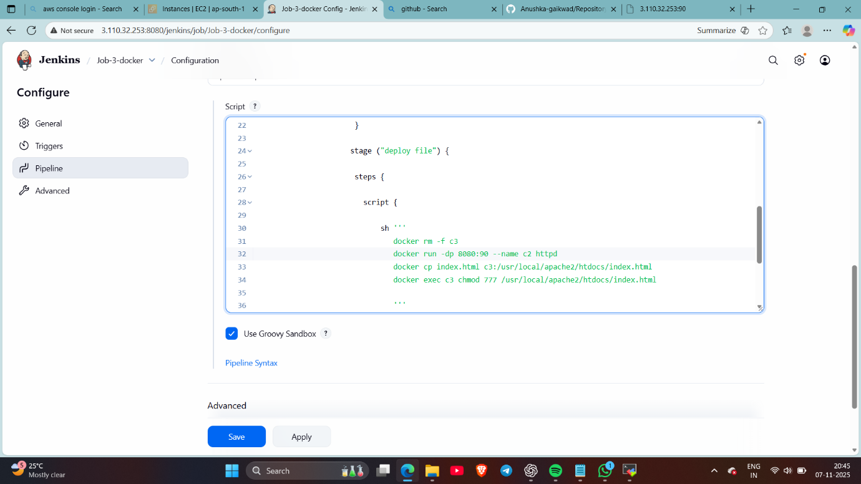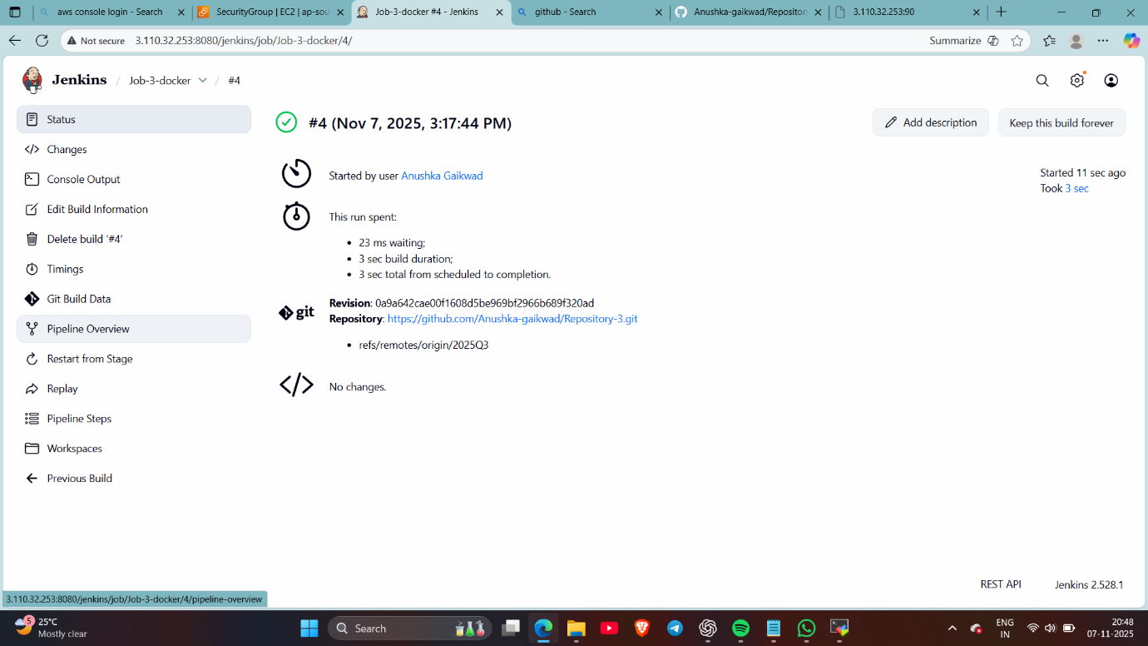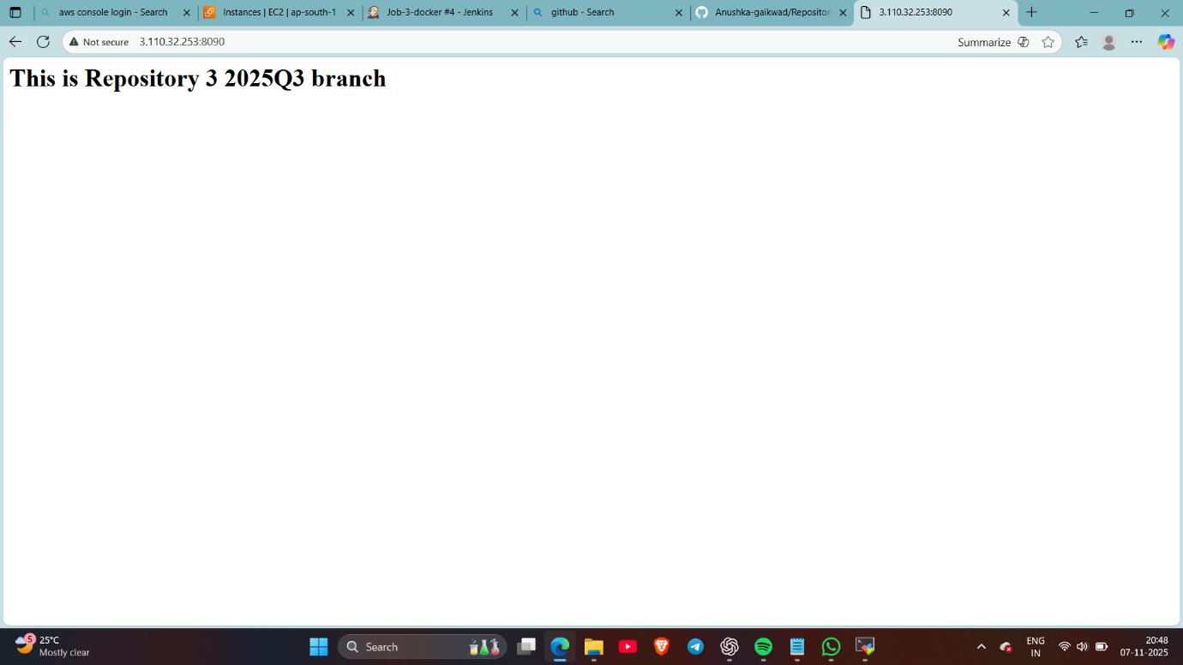

Done……

